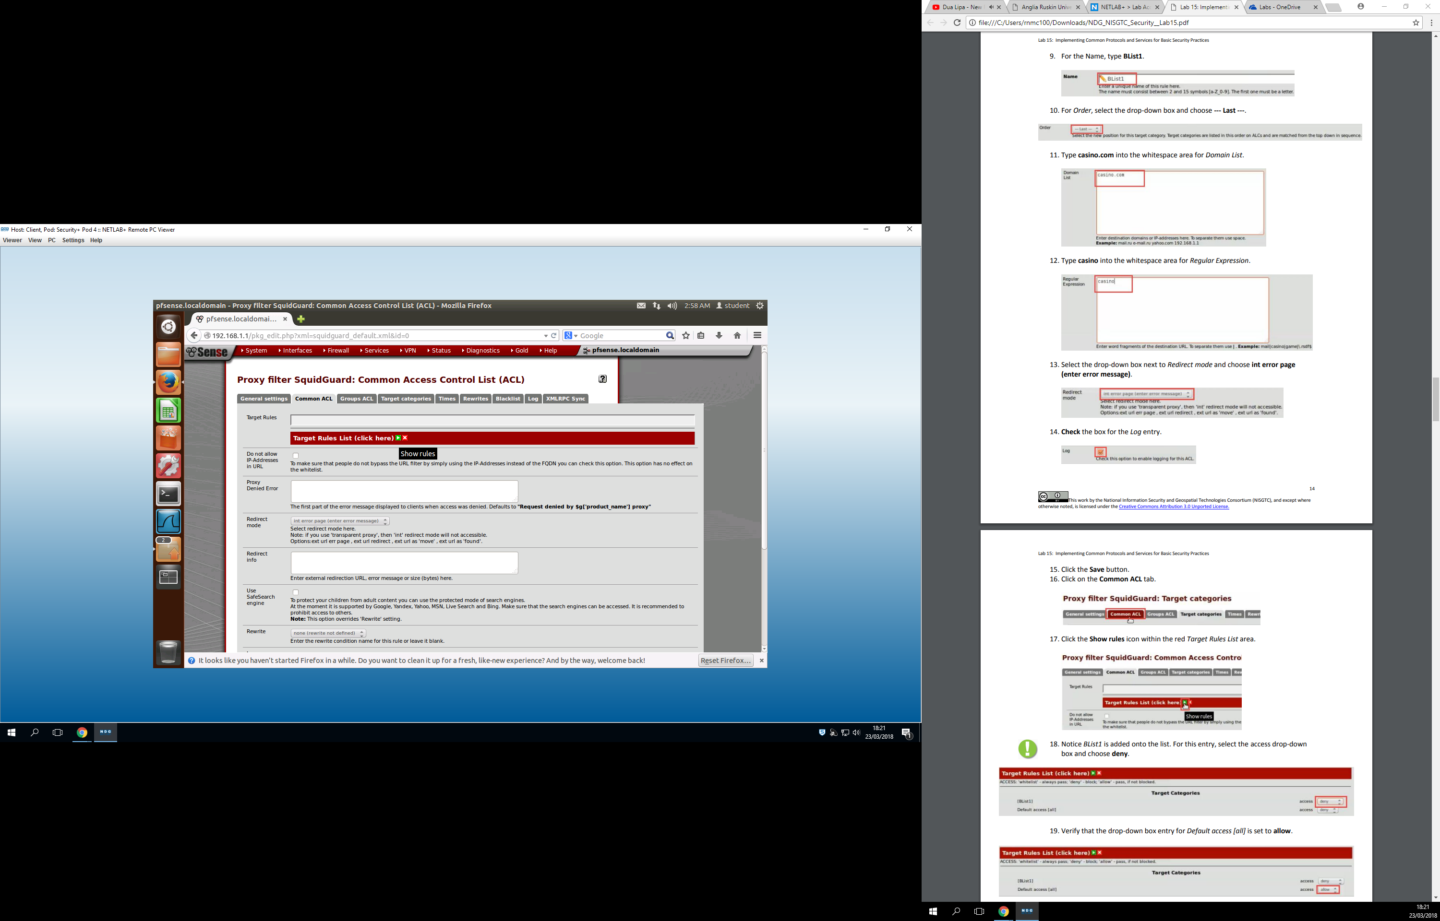

Here we have blocked the address field casino.com

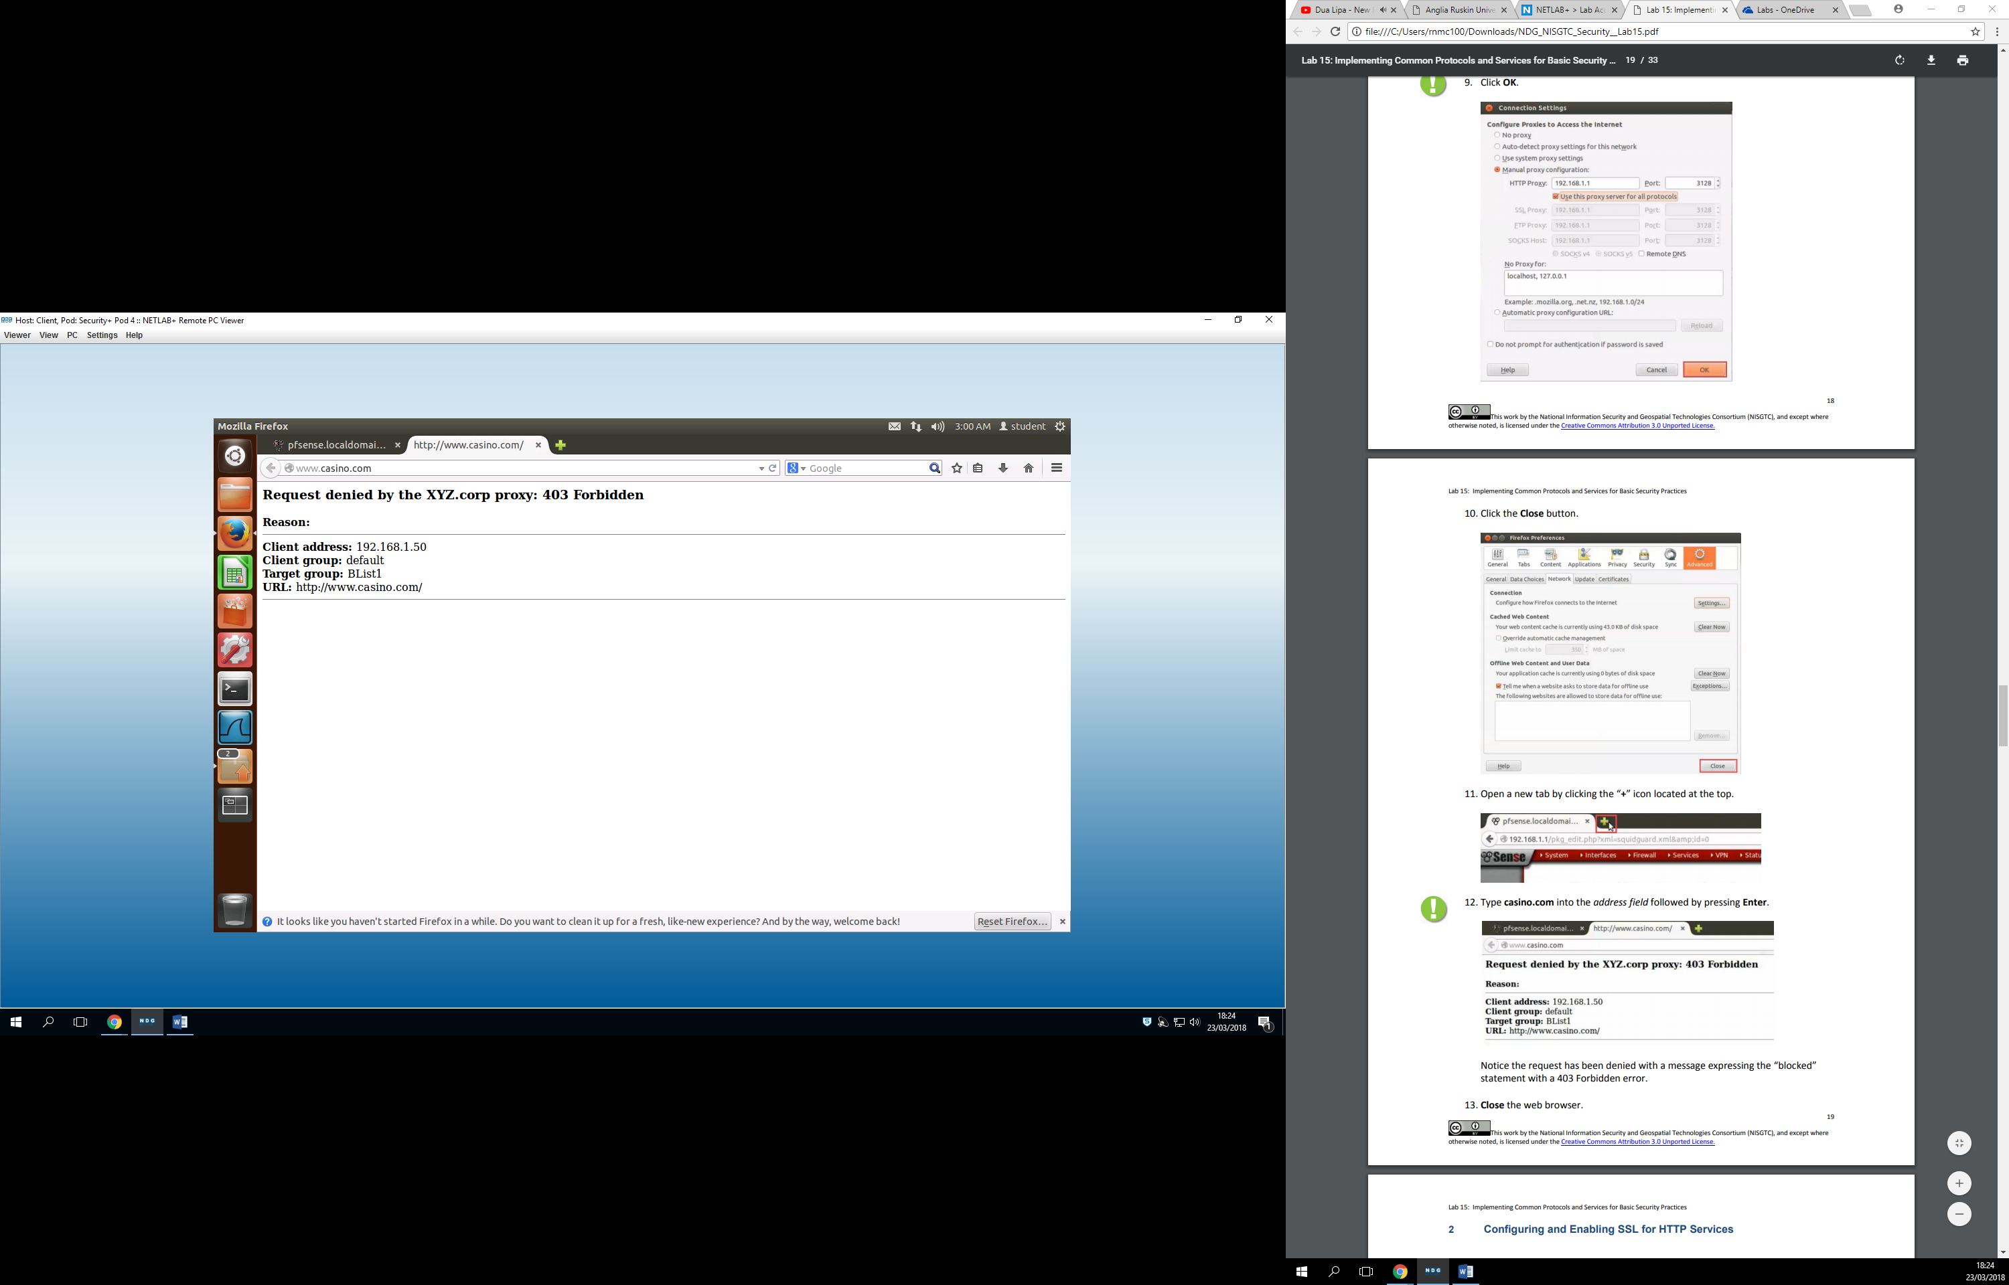

On this one we can see the contents that the server.crt has certified

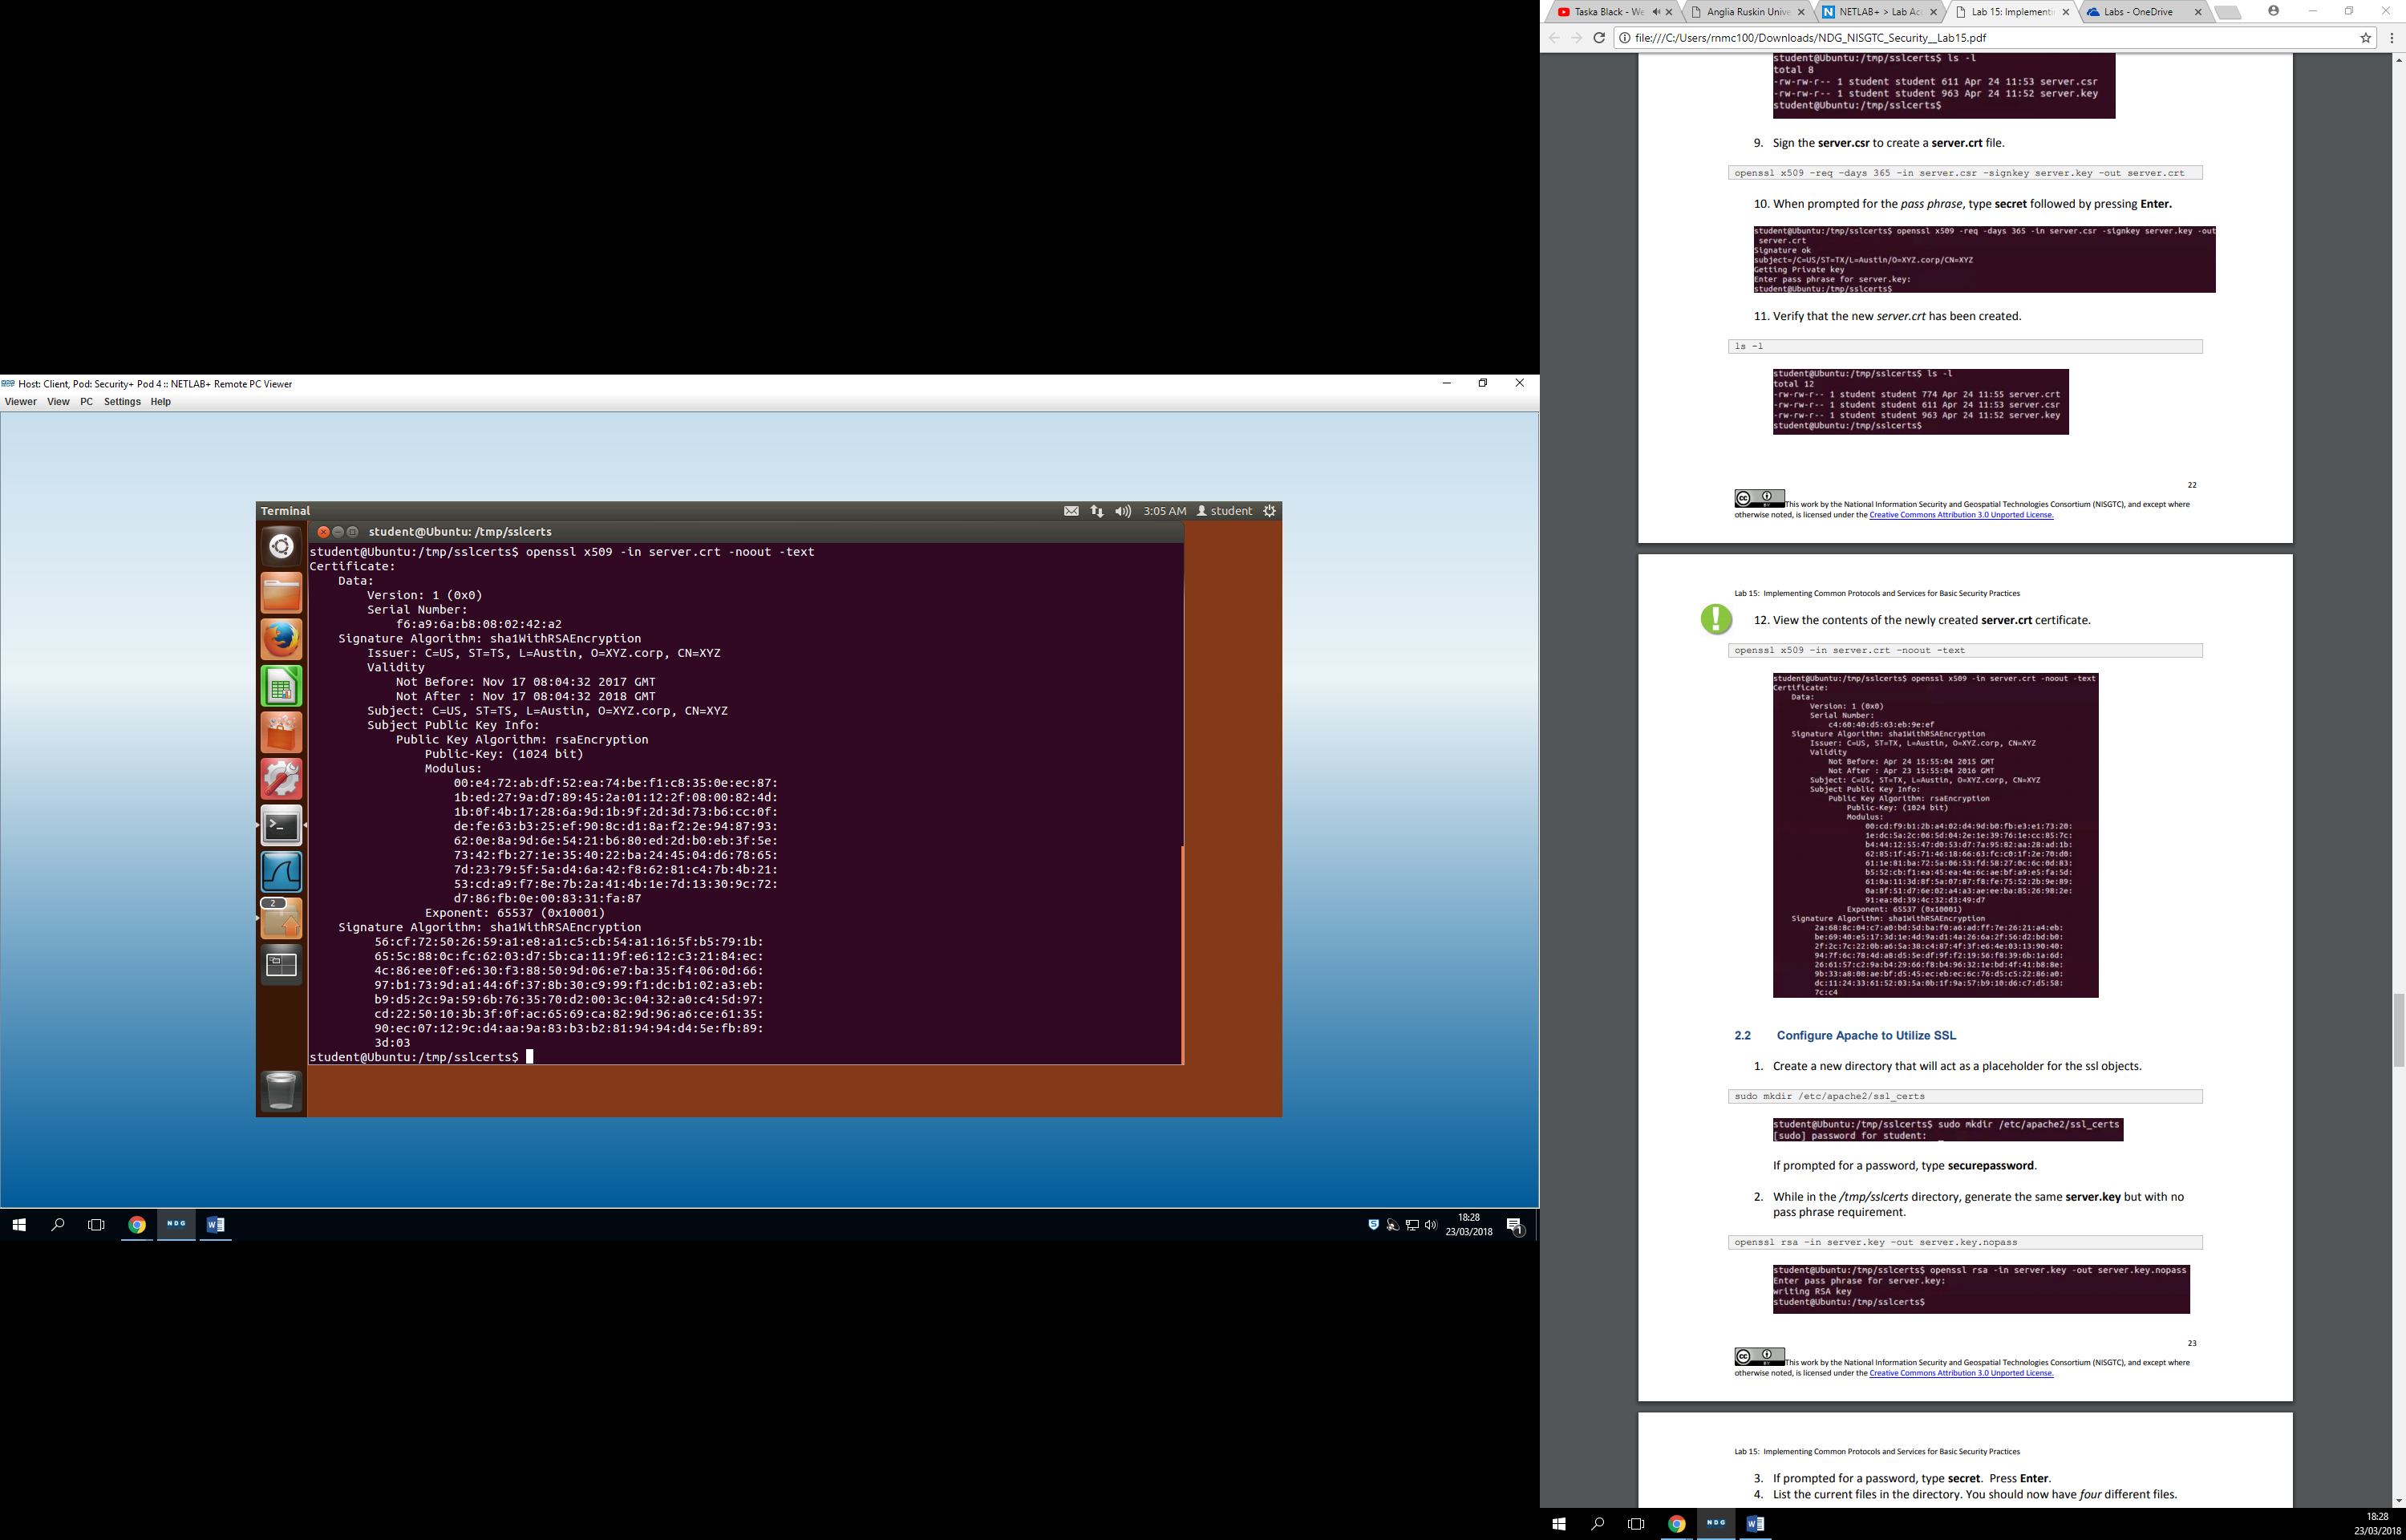

Server name has been set to 192.168.1.0:80

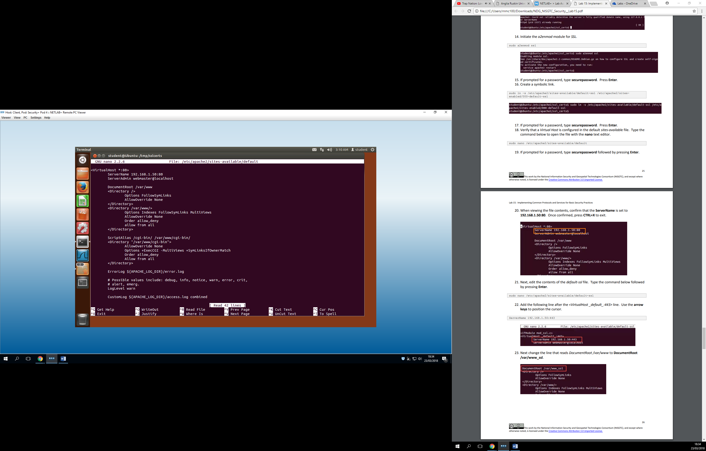

I was able to connect to the website in the end. Unfortunately, as I was taking the screenshot the client stopped working and it turned off my session.

I was having an error when I launched “sudo service apache2 restart” and it said it didn’t know what I was trying to do because the key was empty. This happened because I had forgotten to change the name of the server.key.nopass to server.key. Fortunately enough I was able to spot that error.